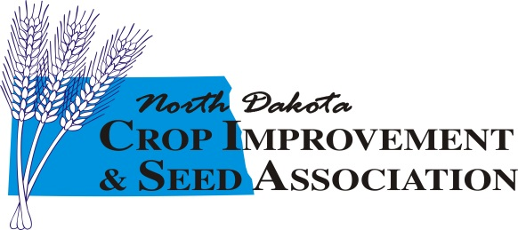
Scholarship Application
(INCOMING FRESHMAN)

Contact Information
Name (First, Middle, Last)
Street Address
City St Zip
County
Phone #
Email Address
High School Attended
GPA

Honors Achieved

Extracurricular Activities

Community Activities (organizations, jobs, church, etc.)

(Page 2 – Incoming Freshman Application)

Please state your career objectives and provide any information you feel might be pertinent to your eligibility for a scholarship.

What school are you planning on attending in the fall (please include the address).

Return application to: North Dakota Crop Improvement & Seed Association
Attn: Toni Muffenbier
PO Box 5084
West Fargo, ND 58078

Application deadline is February 15th

Note: Applicant and/or guardian must be a member of their respective County Crop Improvement Association. Are you and/or your guardian County Crop Improvement members? ______Yes ______ No

Signature Date

